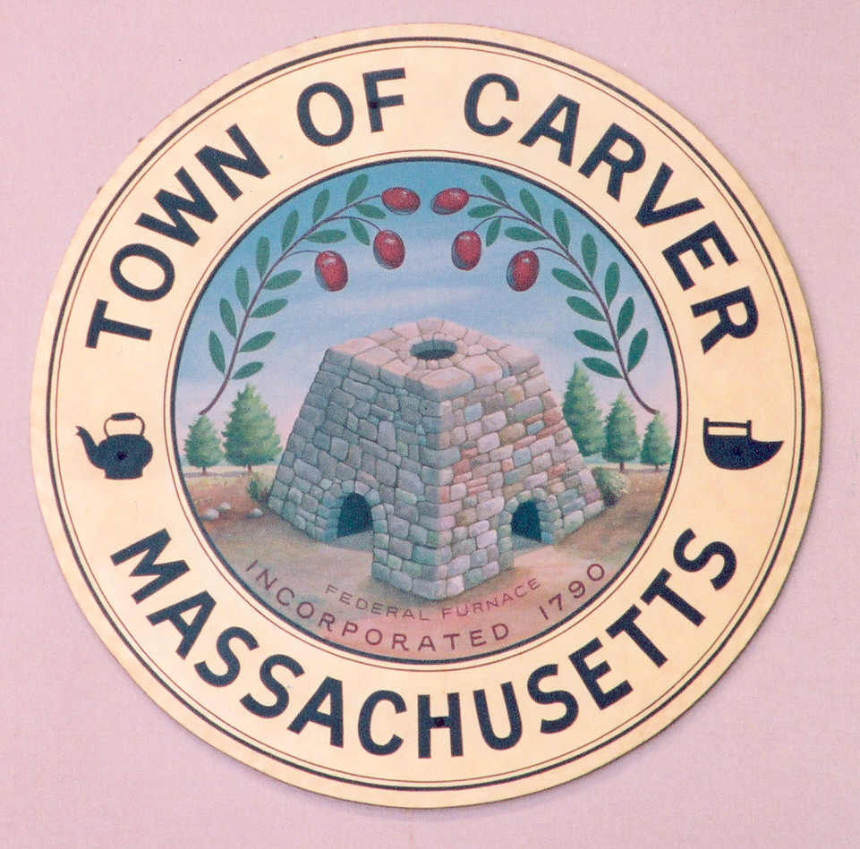
Telephone: 508-866-6160
Fax: 508-866-2920
www.carver.org

Lance Kennedy, Chair
Gina Marie Hanlon-Cavicchi, Vice Chair
Barry Struski, Secretary
Paula Kibbe, Member
James O’Brien, Member
Carver School Committee
Carver Public Schools
3 Carver Square Boulevard
Carver, Massachusetts 02330-1200

SCHOOL COMMITTEE

EXECUTIVE SESSION

Monday, August 12, 2013
6:00 p.m.

Makepeace Literacy Center
School Department Central Office – 1st floor

AGENDA

To discuss strategy with respect to litigation

Lance Kennedy, School Committee Chair 8/7/13

