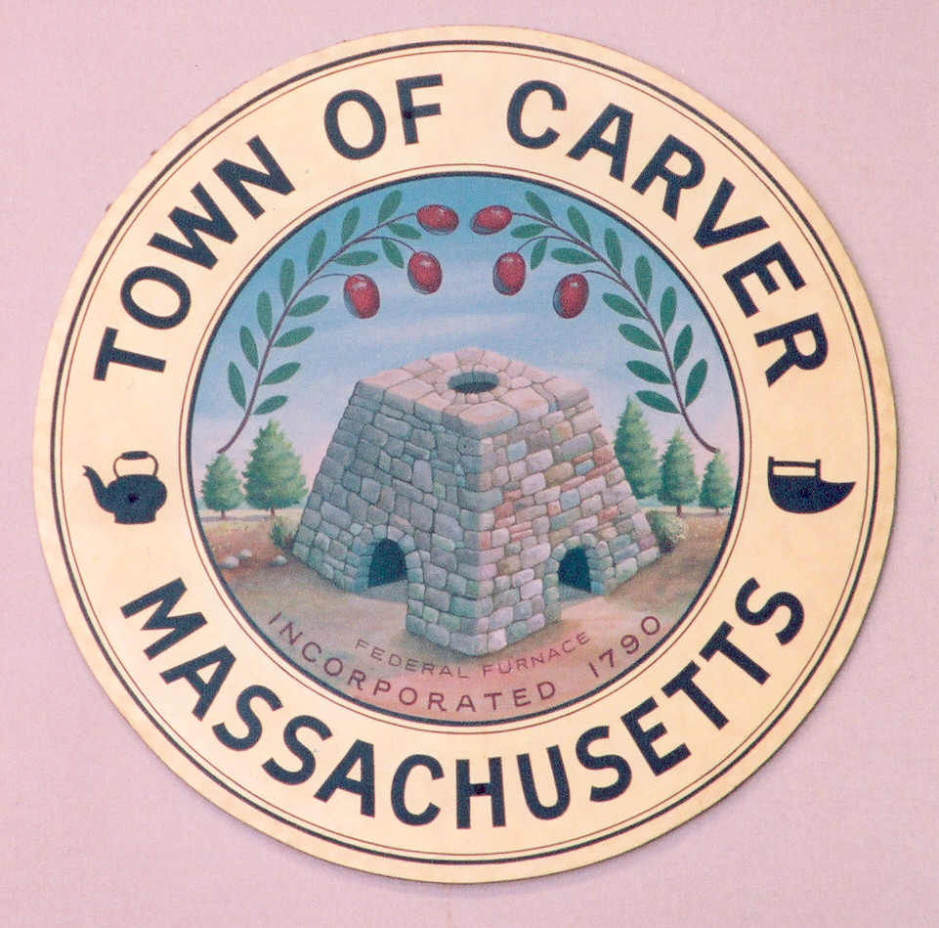
Telephone: 508-866-6160
Fax: 508-866-2920
www.carver.org

Barry Struski Chair
Gina Marie Hanlon-Cavicchi, Vice Chair
Andrew Soliwoda, Secretary
Paula Kibbe, Member
James O’Brien, Member
Carver School Committee
Carver Public Schools
3 Carver Square Boulevard
Carver, Massachusetts 02330-1200

SCHOOL COMMITTEE

EXECUTIVE SESSION

Monday, October 20, 2014
7:00 p.m.

Makepeace Literacy Center
School Department Central Office – 1st floor

AGENDA

To discuss strategy with respect to litigation if an open meeting may have a detrimental effect on the litigating position of the public body and the chair so declares there will be discussions concerning strategy with respect to on-going litigation.

Barry Struski, School Committee Chair 10/15/2014

