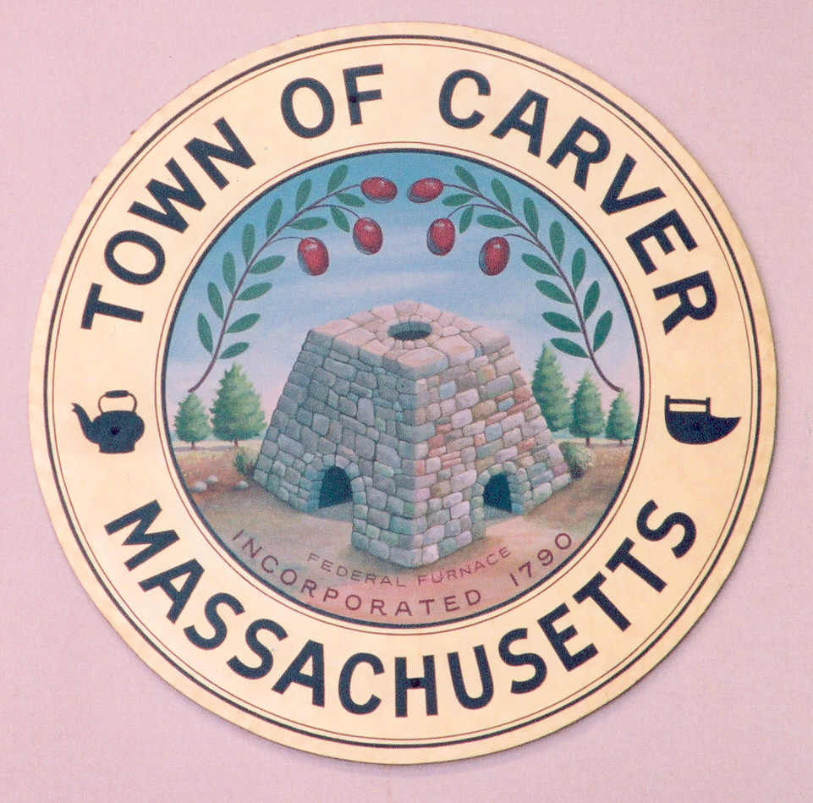
Telephone: 508-866-6160
Fax: 508-866-2920
www.carver.org

Barry Struski, Chair
E. Kay Spencer, Vice Chair
Mary Kaminski, Secretary
Paula Kibbe
Albert Spicer

Carver School Committee
Carver Public Schools
3 Carver Square Boulevard
Carver, Massachusetts 02330-1200

Please Post

NOTICE

School Committee Meeting

Wednesday, January 27, 2010
6:00 p.m.
Middle High School Library

AGENDA

I. Call to Order
II. Comments from the General Public
III. Discussion of Elementary School Project
VI. Executive Session
A. Contract Negotiations-Dir. of Curriculum Instruction and Technology

Barry Struski January 25, 2010
School Committee, Chair

